A-barth Onan Hag Oll |  | Representing One and All

The next Meeting of the Stithians Parish Council will be held on
Tuesday the Seventeenth day of January 2017 at 7pm
in the Hendra Room of the Stithians Centre

THE PUBLIC AND PRESS ARE WELCOME TO ATTEND

AGENDA

1. | Apologies for absence. | Time to be
2. | Notification of Receipt of Urgent Items. | Completed by
3. | Declarations:  - Declarations of interest in Agenda Items.  - Consideration of written requests for dispensation to speak at the meeting.
4.  4.1 | Minutes of Previous Meeting:  Confirmation of the Minutes of the Council Meeting held on 14th December 2016. | 19.05
5.  5.1 | Matters Arising:  Matters arising from the Minutes of the Council Meeting held on 14th December 2016 not covered elsewhere in the agenda. | 19:10
6. | Cornwall Councillor John Thomas. | 19:15
7.  7.1 | Police & NHW:  Police and NHW Liaison Officer’s Report. | 19:20
8. | Public Participation:
8.1 | Matters raised by Members of the Public. The Chairman will be limiting this Item to 30 minutes. This is the only point on the Agenda where Members of the Public are permitted to speak. | 19:50
9. | The future of Post Office Services in Stithians: | 20:05
10.  10.1 | Transport:  Transport Representative’s Report. | 20:10
11. | Parish Development Working Group:  Chairman’s Report.
12. | Clerk’s Reports:
12.1 | Council’s Current Financial Position. | 20:15
13. | Planning:
13.1 | To note Planning Decisions as detailed in the table attached to agenda.
13.2 | To note Planning Decisions received after publication of the Agenda. | 20:20
13.3 | Planning Applications:  - PA16/11334 – Mr M Hearn – Construction of Building for Storing & Cutting Firewood – Land SE of Higher Trolvis Farm.  - PA10/12001 – Mrs D Clements-Mowbray – Demolition of single storey rear extension and replacement with two storey extension – 2 Glendor, New Road.  - PA16/11718 – Mr & Mrs N Stubbs – Retention & completion of dwelling & construction of detached garage – Penhallow Barn, Trewithen Moor.  - PA16/11749 – Condy & Hooper Ltd – Construction of detached dwelling & garage to replace existing dwelling – Lanefield, Carn.  - PA16/12066 – Mr & Mrs Stephens – NMA to glazing, materials and garage to PA15/02272 – Relocation of agricultural dwelling – Tretheague Farm.  - PA16/11153 – Mr D Hand – Change of use of land to domestic curtilage and construction of garage with store over – Farr View Cottage, Tubbin Hill.  - PA16/12123 – Mr M Heap – Cert. of Lawfulness for conversion of outbuildings to self contained dwelling used as holiday let – Little Trebost, Trebost Lane. | 20:50
13.4 | To consider any Planning Applications received after publication of the Agenda.
14. | Licensing:
14.1 | Licensing Applications.
15.  15.1 | New Cemetery:  Clerk’s Report. | 21:00
16.  16.1  16.2  16.3  16.4  16.5  16.6  16.7  16.8 | Footpaths, Highways & Environment:  Environment Portfolio Holder’s Report.  Meeting with Cormac Area Manager – 10th January 2017.  Toilets – Installation of Hand Dryer.  Re-carving of Milestones.  Land behind “At Your Convenience”.  Stithians Energy Group.  Notice Boards.  Post Boxes. | 21:15
17. | Playing Field:
17.1 | Clerk’s Report re Playing Field Progress Meeting – 9th January 2017. | 21:20
18.  18.1 | Consultations:  Cornwall Council - Cornwall Community Infrastructure Levy (CIL) Preliminary Draft Charging Schedule Consultation.
19.  19.1 | Public Relations:  Parish Council Website. | 21:25
20. | Reports of Council Representatives on Outside Bodies etc:
20.1  20.2 | MVRG.  Stithians Centre Management Committee. | 21:30
21. | Correspondence:
 | Correspondence received since the last Meeting.  Also to include correspondence received after publication of the agenda. (Report will be tabled at the meeting) | 21:35
22. | Urgent Items:  Consideration of items ruled as urgent by the Chairman and not considered elsewhere in the agenda.
23. | Authorising of Payments.  Also to include invoices received after publication of the agenda (Report will be tabled at the meeting) and additional expenditure agreed by resolution during the meeting. | 21:40
24. | Items for Next Meeting.
25. | Press Release:  To agree items for inclusion in a Press Release following the meeting. | 21:45
26. | Date of Next Meeting:  To confirm the date of the next meeting of the Full Council as Tuesday 21st February 2017 at 7pm in the Stithians Centre.
27.  27.1 | CONFIDENTIAL ITEMS:  Planning Compliance. | 21:55
 | Given under my hand this Tenth Day of January 2017
 | 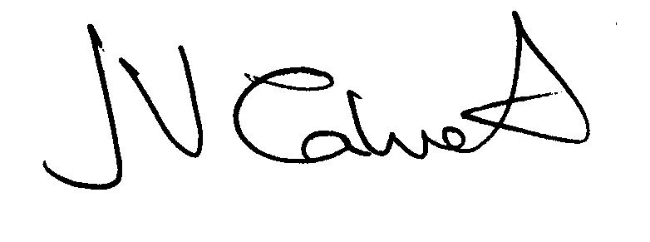 Clerk to the Council

