A-barth Onan Hag Oll |  | Representing One and All

The next Meeting of the Stithians Parish Council will be held on
Tuesday the Twenty First day of March 2017 at 7pm
in the Hendra Room of the Stithians Centre

THE PUBLIC AND PRESS ARE WELCOME TO ATTEND

AGENDA

1. | Apologies for absence. | Time to be
2. | Notification of Receipt of Urgent Items. | Completed by
3. | Declarations:  - Declarations of interest in Agenda Items.  - Consideration of written requests for dispensation to speak at the meeting.
4.  4.1 | Minutes of Previous Meeting:  Confirmation of the Minutes of the Council Meeting held on 21st February 2017 | 19.05
5.  5.1 | Matters Arising:  Matters arising from the Minutes of the Council Meeting held on 21st February 2017 not covered elsewhere in the agenda. | 19:10
6. | Cornwall Councillor John Thomas. | 19:15
7.  7.1 | Police & NHW:  Police and NHW Liaison Officer’s Report. | 19:20
8. | Public Participation:
8.1 | Matters raised by Members of the Public. The Chairman will be limiting this Item to 15 minutes. This is the only point on the Agenda where Members of the Public are permitted to speak. | 19:35
9. | Stithians Energy Group: | 19:40
10.  10.1 | Transport:  Transport Representative’s Report. | 19:45
11. | Parish Development Working Group:
12. | Clerk’s Reports:
12.1 | Council’s Current Financial Position. | 19:50
13. | Planning:
13.1 | To note Planning Decisions as detailed in the table attached to agenda.
13.2 | To note Planning Decisions received after publication of the Agenda. | 19:55
13.3 | Planning Applications:  - PA17/01300 – WF Gluyas & Son – Construction of Agricultural Building for Beef Cattle (Cattle Shed A) on Agricultural Land – Pencoose Farm.  - PA17/01301 – WF Gluyas & Son – Construction of Agricultural Building for Beef Cattle (Cattle Shed A) on Agricultural Land – Pencoose Farm.  - PA17/01387 – Mr A Hearn – Demolition of Nissen Hut & Construction of Replacement Building for purposes incidental to enjoyment of dwelling – Higher Trolvis Farm.  - PA17/01456 – Mr C Davidson – Insertion of campsite facilities into partially redundant agricultural pole barn – Calamankey Farm, Longdowns. | 20:10
13.4 | To consider any Planning Applications received after publication of the Agenda.
14. | Licensing:
14.1 | Licensing Applications.
15.  15.1 | New Cemetery:  Clerk’s Report. | 20:15
16.  16.1  16.2  16.3  16.4  16.5  16.6  16.7 | Footpaths, Highways & Environment:  Environment Portfolio Holder’s Report.  Footpath 2.  Land surrounding driveway to Crellow House.  “At Your Convenience”.  Notice Boards.  Post Boxes.  Litter between Pelean Cross and Village. | 20:30
17. | Playing Field:
17.1  17.2  17.3 | Clerk’s Report re Playing Field Progress Meeting – 13th March 2017.  Moles in the Playing Field.  Playing Field and Other Signs. | 20:40
18.  18.1 | Consultations:  None.
19.  19.1  19.2 | Public Relations:  Parish Council Website.  Use of Social Media. | 20:55
20. | Reports of Council Representatives on Outside Bodies etc:
20.1  20.2 | MVRG.  Stithians Centre Management Committee.
21. | Correspondence:
 | Correspondence received since the last Meeting.  Also to include correspondence received after publication of the agenda. (Report will be tabled at the meeting) | 21:00
22. | Urgent Items:  Consideration of items ruled as urgent by the Chairman and not considered elsewhere in the agenda.
23. | Authorising of Payments.  Also to include invoices received after publication of the agenda (Report will be tabled at the meeting) and additional expenditure agreed by resolution during the meeting. | 21:05
24. | Items for Next Meeting.
25. | Press Release:  To agree items for inclusion in a Press Release following the meeting.
26. | Date of Next Meeting:  To confirm the date of the next meeting of the Full Council as Tuesday 18th April 2017 at 7pm in the Stithians Centre.
27.  27.1 | CONFIDENTIAL ITEMS:  Planning Compliance. | 21:15
 | Given under my hand this Fourteenth Day of March 2017
 | 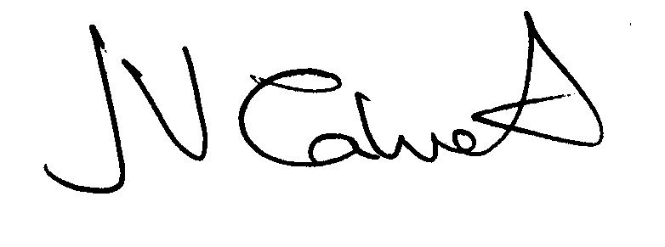 Clerk to the Council

