A-barth Onan Hag Oll |  | Representing One and All

TO: All Members of Stithians Parish Council
Dear Councillor,
I hereby summon you to attend a Meeting of the Stithians Parish Council to be held on
Tuesday, the Eighteenth day of October 2016 at 7pm
in the Hendra Room of the Stithians Centre
AGENDA

1. | Apologies for absence. | Time to be
2. | Notification of Receipt of Urgent Items. | Completed by
3. | Declarations:  - Declarations of interest in Agenda Items.  - Consideration of written requests for dispensation to speak at the meeting.
4.  4.1 | Minutes of Previous Meeting:  Confirmation of the Minutes of the Council Meeting held on 20th September 2016. | 19.05
5.  5.1 | Matters Arising:  Matters arising from the Minutes of the Council Meeting held on 20th September 2016 not covered elsewhere in the agenda. | 19:10
6. | Cornwall Councillor John Thomas. | 19:15
7.  7.1 | Police & NHW:  Police and NHW Liaison Officer’s Report. | 19:20
8. | Public Participation:
8.1 | Matters raised by Members of the Public. The Chairman will be limiting this Item to 15 minutes. This is the only point on the Agenda where Members of the Public are permitted to speak. | 19:35
9.  9.1 | Transport:  Transport Representative’s Report. | 19:40
10. | Parish Development Working Group:
11. | Clerk’s Reports:
11.1  11.2  11.3 | Council’s Current Financial Position.  2017/18 Budget.  Remembrance Day Parade. | 19:55
12. | Planning:
12.1 | To note Planning Decisions as detailed in the table attached to agenda.
12.2 | To note Planning Decisions received after publication of the Agenda. | 20:00
12.3 | Planning Applications:  - PA16/09255 – Mr WH Lees – Application for Agricultural Building – Trethellan Vean, Trethellan. | 20:05
12.4 | To consider any Planning Applications received after publication of the Agenda.
13. | Licensing:
13.1 | Licensing Applications.
14.  14.1 | New Cemetery:  Clerk’s Report. | 20:10
15.  15.1  15.2  15.3  15.4  15.5  15.6  15.7 | Footpaths, Highways & Environment:  Environment Portfolio Holder’s Report.  Toilet Conversion for Stithians Post Office.  Crellow Fields Amenity Area.  Notice Boards.  Longdowns Bus Shelters.  Gritting Routes.  Post Boxes. | 20:20
16. | Playing Field:
16.1  16.2 | Clerk’s Report re Playing Field Progress Meeting – 10th October 2016.  Stithians Fayre Day 2017. | 20:30
17. | Consultations:  None.
18.  18.1  18.2 | Public Relations:  Website Hits.  Parish Council Website. | 20:40
19. | Reports of Council Representatives on Outside Bodies etc:
19.1  19.2  19.3 | MVRG – Meeting held on 22nd September 2017.  Stithians Centre Management Committee.  CALC “Open Meeting” – 6th October 2016. | 20:45
20. | Correspondence:
 | Correspondence received since the last Meeting.  Also to include correspondence received after publication of the agenda. (Report will be tabled at the meeting) | 20:50
21. | Urgent Items:  Consideration of items ruled as urgent by the Chairman and not considered elsewhere in the agenda.
22. | Authorising of Payments.  Also to include invoices received after publication of the agenda (Report will be tabled at the meeting) and additional expenditure agreed by resolution during the meeting. | 20:55
23. | Items for Next Meeting.
24. | Press Release:  To agree items for inclusion in a Press Release following the meeting. | 21:00
25. | Date of Next Meeting:  To confirm the date of the next meeting of the Full Council as Tuesday 15th November 2016 at 7pm in the Stithians Centre.
26.  26.1 | CONFIDENTIAL ITEMS:  Planning Compliance. | 21:10
 | Given under my hand this Eleventh Day of October 2016
 | 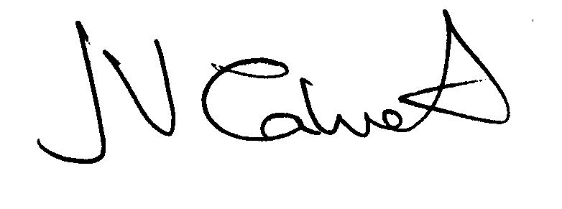 Clerk to the Council

