A-barth Onan Hag Oll |  | Representing One and All

TO: All Members of Stithians Parish Council
Dear Councillor,
I hereby summon you to attend a Meeting of the Stithians Parish Council to be held on
Tuesday, the Seventeenth day of May 2016 immediately following the AGM
in the Hendra Room of the Stithians Centre
AGENDA

1. | Apologies for absence. | Time to be
2. | Notification of Receipt of Urgent Items. | Completed by
3. | Declarations:  - Declarations of interest in Agenda Items.  - Consideration of written requests for dispensation to speak at the meeting.
4.  4.1 | Minutes of Previous Meeting:  Confirmation of the Minutes of the Council Meeting held on 19th April 2016. | 19.35
5.  5.1 | Matters Arising:  Matters arising from the Minutes of the Council Meeting held on 19th April 2016 not covered elsewhere in the agenda. | 19:40
6. | Cornwall Councillor John Thomas. | 19:45
7.  7.1 | Police & NHW:  Police and NHW Liaison Officer’s Report.
8. | Public Participation:
8.1 | Matters raised by Members of the Public. The Chairman will be limiting this Item to 15 minutes. This is the only point on the Agenda where Members of the Public are permitted to speak. | 20:00
9.  9.1 | Transport:  Transport Representative’s Report. | 20:05
10. | Parish Development Working Group:
11. | Clerk’s Reports:
11.1  11.2  11.3 | Council’s Current Financial Position.  Toilet Conversion for Stithians Post Office.  Review of Toilet Cleaning Contract. | 20:15
12. | Planning:
12.1 | To note Planning Decisions as detailed in the table attached to agenda. | 20:20
12.2 | To note Planning Decisions received after publication of the Agenda.
12.3 | Planning Applications:  - PA16/02279 – Mr & Mrs Giorgio & Sarah Ferrantte – Conversion of residential stores to holiday accommodation – Little Trewince, Herniss Lane. | 20:25
12.4 | To consider any Planning Applications received after publication of the Agenda.
12.5 | Planning Appeal Submissions:  - Penhalurick Barton Solar Farm.  - Barn Conversion at Trewithen. | 20:45
13. | Licensing:
13.1 | Licensing Applications.
14.  14.1 | New Cemetery:  Clerk’s Report. | 20:50
15.  15.1  15.2  15.3  15.4 | Footpaths, Highways & Environment:  Environment Portfolio Report.  Meeting with Cormac Area Manager – 3rd May 2016.  Crellow Fields Amenity Area.  Institute Notice Board. | 21:00
16. | Playing Field:
16.1 | Clerk’s Report re Playing Field Progress Meeting – 9th May 2016. | 21:05
17.  17.1 | Consultations:  Cornwall Council - Gypsy and Travelling Communities Site Allocations Development Plan Document Scoping Report Consultation. | 21:15
18. | Public Relations:
19. | Reports of Council Representatives on Outside Bodies etc:
19.1  19.2 | MVRG/CNA – 17th March & 12th May 2016.  Stithians Centre Management Committee | 21:20
20. | Correspondence:
 | Correspondence received since the last Meeting.  Also to include correspondence received after publication of the agenda. (Report will be tabled at the meeting) | 21:25
21. | Urgent Items:  Consideration of items ruled as urgent by the Chairman and not considered elsewhere in the agenda.
22. | Authorising of Payments.  Also to include invoices received after publication of the agenda (Report will be tabled at the meeting) and additional expenditure agreed by resolution during the meeting. | 21:30
23. | Items for Next Meeting.
24. | Press Release:  To agree items for inclusion in Press Release following the meeting. | 21:35
25. | Date of Next Meetings:  To confirm the date of the next meeting of the Full Council as MONDAY 13th JUNE at 7pm in the Stithians Centre.
26.  26.1 | CONFIDENTIAL ITEMS:  Planning Compliance. | 21:45
 | Given under my hand this Tenth Day of May 2016
 | 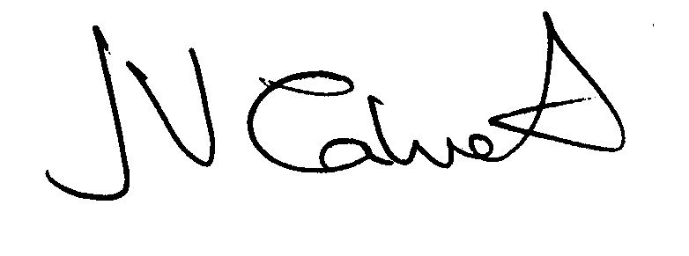 Clerk to the Council

