A-barth Onan Hag Oll |  | Representing One and All

TO: All Members of Stithians Parish Council
Dear Councillor,
I hereby summon you to attend a Meeting of the Stithians Parish Council to be held on
Tuesday, the Nineteenth day of July 2016 at 7pm
in the Hendra Room of the Stithians Centre
AGENDA

1. | Apologies for absence. | Time to be
2. | Notification of Receipt of Urgent Items. | Completed by
3. | Declarations:  - Declarations of interest in Agenda Items.  - Consideration of written requests for dispensation to speak at the meeting.
4.  4.1 | Minutes of Previous Meeting:  Confirmation of the Minutes of the Council Meeting held on 9th June 2016. | 19.05
5.  5.1 | Matters Arising:  Matters arising from the Minutes of the Council Meeting held on 9th June 2016 not covered elsewhere in the agenda. | 19:10
6. | Cornwall Councillor John Thomas. | 19:15
7.  7.1 | Police & NHW:  Police and NHW Liaison Officer’s Report including Police Liaison Group Meeting held on 8th June. | 19:20
8. | Public Participation:
8.1 | Matters raised by Members of the Public. The Chairman will be limiting this Item to 15 minutes. This is the only point on the Agenda where Members of the Public are permitted to speak. | 19:35
9.  9.1 | Transport:  Transport Representative’s Report. | 19:40
10. | Parish Development Working Group:
11. | Clerk’s Reports:
11.1 | Council’s Current Financial Position. | 19:45
12. | Planning:
12.1 | To note Planning Decisions as detailed in the table attached to agenda.
12.2 | To note Planning Decisions received after publication of the Agenda.
12.3 | Planning Applications:  - PA16/05128 – Geza Toth-Feher, Lord of Kennal – LBC for brickwork repairs in walled garden and chimney stack and reopening bricked up window – Tretheague House.  - PA16/05577 – Mr I Moyle - Proposed Conservatory - Ferndale, 5 Rose Meadow.  - PA16/05446 – Mrs E Bagley - Installation of free standing Static Home for use by Elderly Relatives -Trevales Lodge. | 20:00
12.4 | To consider any Planning Applications received after publication of the Agenda.
12.5 | Dealing with Planning Applications received in August. | 20:05
13. | Licensing:
13.1 | Licensing Applications.
14.  14.1 | New Cemetery:  Clerk’s Report. | 20:15
15.  15.1  15.2  15.3  15.4  15.5 | Footpaths, Highways & Environment:  Environment Portfolio Holder’s Report.  Meeting with Cormac Area Manager – 5th July 2016.  Toilet Conversion for Stithians Post Office.  Crellow Fields Amenity Area.  Institute Notice Board. | 20:30
16. | Playing Field:
16.1 | Clerk’s Report re Playing Field Progress Meeting – 12th July 2016. | 20:35
17.  17.1 | Consultations:  Cornwall Council – Post-Hearing Changes to Cornwall Local Plan. | 20:45
18.  18.1  18.2 | Public Relations:  Clerk’s Report re Website Hits.  Parish Council Website.
19. | Reports of Council Representatives on Outside Bodies etc:
19.1  19.2 | MVRG/CNA.  Stithians Centre Management Committee Meeting held on 6th July 2016. | 20:50
20. | Correspondence:
 | Correspondence received since the last Meeting.  Also to include correspondence received after publication of the agenda. (Report will be tabled at the meeting) | 20:55
21. | Urgent Items:  Consideration of items ruled as urgent by the Chairman and not considered elsewhere in the agenda.
22. | Authorising of Payments.  Also to include invoices received after publication of the agenda (Report will be tabled at the meeting) and additional expenditure agreed by resolution during the meeting. | 21:00
23. | Items for Next Meeting.
24. | Press Release:  To agree items for inclusion in Press Release following the meeting. | 21:05
25. | Date of Next Meeting:  To confirm the date of the next meeting of the Full Council as Tuesday 20th September 2016 at 7pm in the Stithians Centre.
26.  26.1  26.2 | CONFIDENTIAL ITEMS:  Planning Compliance.  Co-option of New Members. | 21:15
 | Given under my hand this Twelfth Day of July 2016
 | 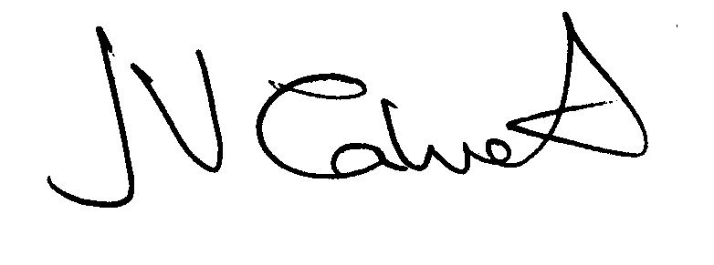 Clerk to the Council

